**Address**: 3215 Bridge Road Suite 4

Suffolk, VA 23435

Phone: 757.679.3399

**E-mail address**: charmink300@yahoo.com



*Take a look inside*

*&*

*See all that we have to offer*

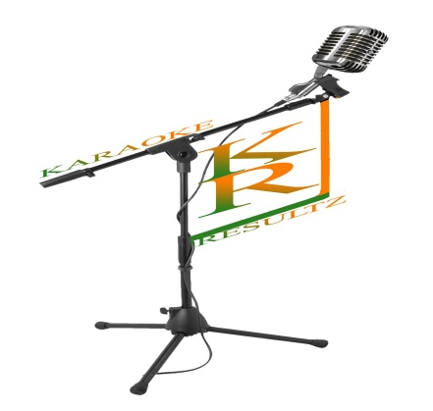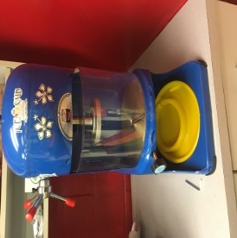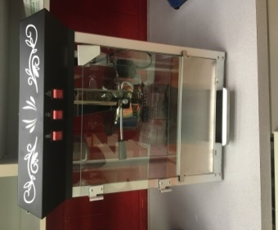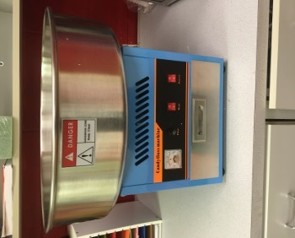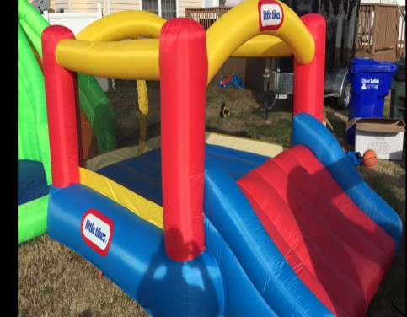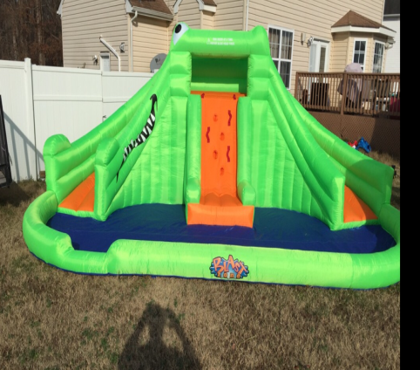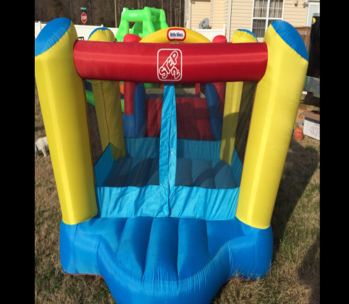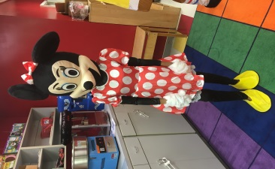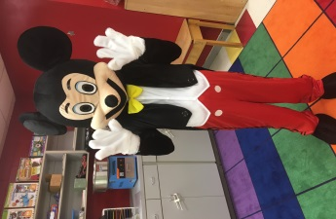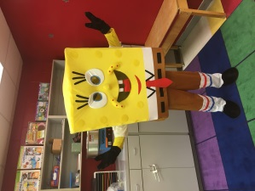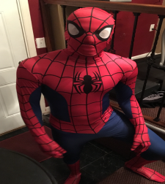

# *“Giving you superior resultz for all of your party needs!!”*



PACKAGES

Facility & Food * $150 ⃝

Entrée (pizza or hotdog)

Side (chips & juice)

Popcorn Machine $50 ⃝

Cotton Candy Machine $50 ⃝

Snow Cone Machine $50 ⃝

Karaoke/DJ $350 ⃝

(3 hours, $100/ addt’l hour)

Bounce House $100 ⃝

( w/ water slide)

Small Bounce House $50 ⃝

Spider Man Character $50 ⃝

Mickey Mouse Character $50 ⃝

Minnie Mouse Character $50 ⃝

SpongeBob Character $50 ⃝

Total $_________

* The price listed above is for up to 10 children. For each additional child, there will be a $5 fee.

BIRTHDAY PARTY RESULTZ